|  |
| --- |
| **Toddler Classroom Assessment Scoring System® (CLASS®) Self-Reflection Guide** |

**Teacher’s Name(s): _______________________________________________ Classroom: ______________________________________________  
  
Program: ______________________________________________________________ Date: ______________________________________________   
  
What is Toddler CLASS?**The Toddler Classroom Assessment Scoring System® (CLASS®) focuses on the effectiveness and quality of teacher-child interactions for children 15 months to 35 months. This includes: 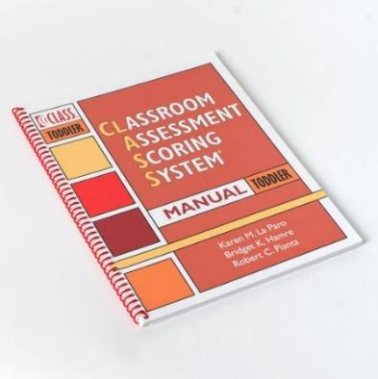

* The connection and positive interactions between the teachers and the children
* How teachers recognize and are responsive to children’s individual needs
* The extent to which children’s interests and points of view are incorporated
* The teacher’s ability to promote appropriate behavior using positive behavior guidance techniques
* The teachers’ ability to motivate and facilitate learning, development and engagement
* How teachers provide feedback to expand children’s participation
* The presence of quality opportunities to support children’s growing language development

**What is the Purpose of Self-Reflection?**This self-reflection guide is developed to help you become more familiar with the Toddler CLASS® measure and reflect on your current practices around teacher-child interactions. This guide can be used independently by teachers and classroom teams or it can be used with support from Technical Assistance Providers. Be as open and honest as you can during this self-reflection process.

**How does the Self-Reflection Guide work?**  
The self-reflection guide includes statements and open-ended questions for you to read and reflect on. This allows you to identify strengths and areas for growth in your caregiving interactions. Throughout this guide, a rating of **rarely, occasionally, or regularly** will be noted based on the consistency of your behaviors or interactions described for each dimension.

|  |
| --- |
| **KEEP IN MIND** |
| There are different ways to reflect on the frequency of your practices. Depending how you decide to use this self-reflection guide, you could have different answers.   * How often does something occur during your day as a whole? * How often does something occur during one time of day (e.g. transitions, mealtime, free play, group time, etc.)? |

This guide was organized to align with the two Toddler CLASS® domains and eight dimensions as shown below:

|  |  |
| --- | --- |
| **Emotional and Behavioral Support** | **Engaged Support for Learning** |
| Positive Climate  Negative Climate  Teacher Sensitivity  Regard for Child Perspectives | Facilitation of Learning and Development  Quality of Feedback  Language Modeling |

The **Emotional and Behavioral Support** Domain assesses interactions between teachers, children and peers that promote a positive classroom climate, including positive relationships and respect. This domain measures teacher’s acknowledgment of children’s feelings or emotions, their awareness and support of children’s academic, social and emotional needs, their promotion of children’s independence, their emphasis on children’s interests, ideas and points of view, and their guidance of children as they learn to regulate their behaviors.

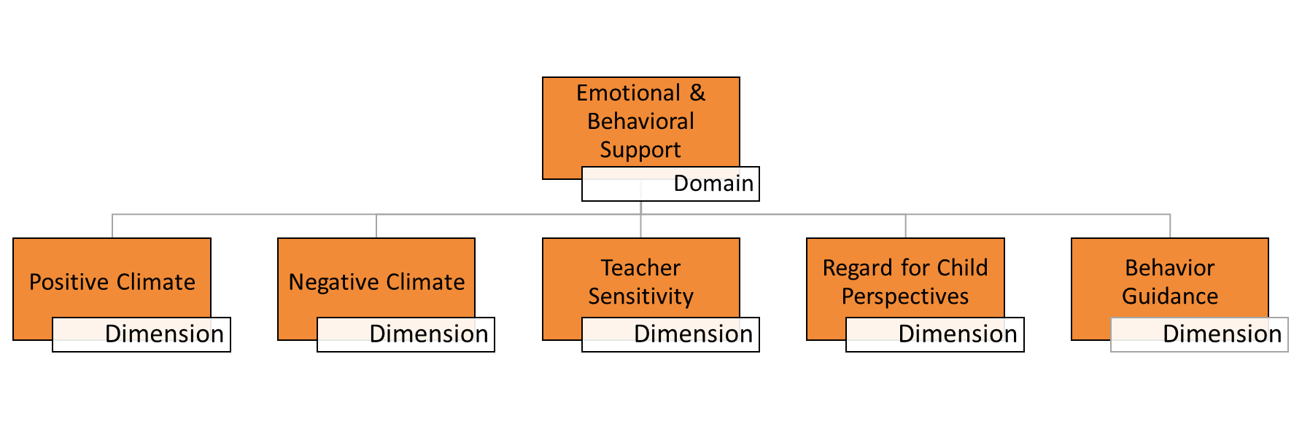

|  |  |  |  |
| --- | --- | --- | --- |
| **Positive Climate** includes three indicators that measure the connection between the teachers and the children. | | | |
|  | Rarely | Occasionally | Regularly |
| I sit next to the children on their level and join in play and activities with them. |  |  |  |
| I smile and laugh with the children frequently. |  |  |  |
| I use a warm, calm voice when speaking with children and use their names when addressing them. |  |  |  |
| How do I build warm, supportive relationships with each child I work with? | | | |
| How am I encouraging positive interactions and relationships among children? | | | |

|  |  |  |  |
| --- | --- | --- | --- |
| **Negative Climate** dimension has four indicators that measure the overall level of expressed negativity in the classroom. | | | |
|  | Rarely | Occasionally | Regularly |
| I express irritation or frustration towards children through words, tone of voice, or body language. |  |  |  |
| I yell, use threats or physical actions to control children. |  |  |  |
| I tease children or criticize them in front of their peers. |  |  |  |
| How are my attitudes and emotions shaping the learning environment? | | | |
| In what ways might my interactions negatively impact the children or group? | | | |

|  |  |  |  |
| --- | --- | --- | --- |
| **Teacher Sensitivity** dimension includes the following three indicators that measure how sensitive a teacher is to children’s cues and needs. | | | |
|  | Rarely | Occasionally | Regularly |
| I am aware of how the children are feeling and take this into consideration during activities. |  |  |  |
| I quickly respond to children’s needs for attention, comfort, or assistance. |  |  |  |
| My children are comfortable seeking support from and interacting with me. |  |  |  |
| What do I do during an activity when I notice a lack of understanding and/or difficulties? | | | |
| How do I address children’s problems and concerns, so they do not continue and are resolved? | | | |

|  |  |  |  |
| --- | --- | --- | --- |
| **Regard for Child Perspectives** includes three indicators that measure how teachers incorporate the children’s points of view and encourage responsibility. | | | |
|  | Rarely | Occasionally | Regularly |
| I let children choose where and what they want to play with, and I also provide choices for them within activities. |  |  |  |
| I encourage children to share their ideas and incorporate those ideas into activities. |  |  |  |
| I am flexible and allow children to join and leave activities based on their interests. |  |  |  |
| How do I encourage children’s independence in the classroom (e.g. children can access materials without help from teachers, put personal belongings into cubbies, snack helper, etc.)? | | | |
| How do I support children in recognizing and understanding the feelings of others? How do I involve them when working through peer conflicts? | | | |

|  |  |  |  |
| --- | --- | --- | --- |
| **Behavior Guidance** has three indicators that measure a teacher’s ability to support and guide children’s behavior using positive behavior guidance techniques. | | | |
|  | Rarely | Occasionally | Regularly |
| I communicate clear behavior expectations for children before all activities/routines. |  |  |  |
| I effectively, and positively, redirect problem behavior before it escalates. |  |  |  |
| I use positive phrases that indicate what the children should be doing rather than referring to behaviors that are not allowed (e.g. “Gentle hands,” instead of “No hitting”). |  |  |  |
| How do I keep children involved in activities? What are some signs that show me they are not engaged or actively participating in an activity? | | | |
| How do I ensure that children are always being monitored and attended to? What if I am working with an individual child or small group? | | | |

The **Engaged Support for Learning** Domain assesses how teachers support learning by providing opportunities for exploration and involvement. This domain measures how teachers use language to label, explain, and expand information, how they encourage language use and thinking skills and use advanced vocabulary. It also looks at teachers providing children with the amount of help they need, and the quality of teacher feedback that acknowledges children’s attempts and increases their involvement.   
 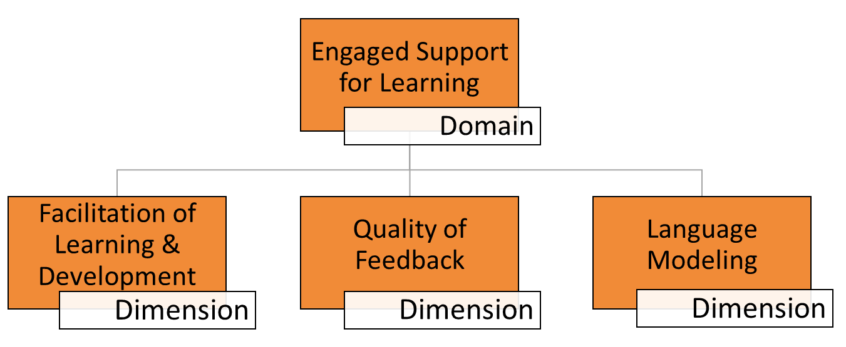

|  |  |  |  |
| --- | --- | --- | --- |
| **Facilitation of Learning and Development** includes three indicators to measure intentional facilitation strategies that teachers use to gain learning and development from the children, using the following three indicators: | | | |
|  | Rarely | Occasionally | Regularly |
| I provide multiple opportunities for children to explore a variety of materials and activities. |  |  |  |
| I actively participate with children during their activities by asking questions that encourage them to think. |  |  |  |
| I connect activities and play to children’s life experiences and previous learning. |  |  |  |
| How do I ensure children are actively involved in activities and routines? | | | |
| How do I incorporate learning opportunities into classroom routines (diaper changes, toileting, mealtimes, etc.)? | | | |

|  |  |  |  |
| --- | --- | --- | --- |
| **Quality of Feedback** includes three to measure a teacher’s use of feedback they give to children in response to their responses or actions, in a way that promotes increased learning, understanding, and participation. | | | |
|  | Rarely | Occasionally | Regularly |
| In response to children’s comments or actions, I ask them to explain what they are doing and why. |  |  |  |
| When asking follow-up questions, I pause and give children ample time to think and respond. |  |  |  |
| Rather than just saying “Good job,” I give children specific feedback that encourages their efforts and persistence in activities (e.g. “You’re working hard on that puzzle”). |  |  |  |
| How do I scaffold when children help to succeed in, participate in, or complete tasks or activities? | | | |
| How do I ensure that the exchanges I have with children are not just simple question and response, but rather promote further learning and understanding on the part of the child? | | | |

|  |  |  |  |
| --- | --- | --- | --- |
| **Language Modeling** includes four indicators that measure the language stimulation and language-facilitation strategies used by the teacher to support children’s language development. | | | |
|  | Rarely | Occasionally | Regularly |
| I provide children with opportunities to use language through conversations and open-ended questioning. |  |  |  |
| I repeat what children say and expand on this by adding a little more language. |  |  |  |
| I use a variety of words with children, describe what unfamiliar words mean, and give them needed words and phrases to use. |  |  |  |
| When do I have back-and-forth exchanges with children? Are there times during the day when this could be happening more? | | | |
| How do I model language for children? | | | |