|  |  |
| --- | --- |
|  | SWHD_Logo_4C.jpg |

|  |
| --- |
| **Pre-K Classroom Assessment Scoring System® (CLASS®) Self-Reflection Guide** |

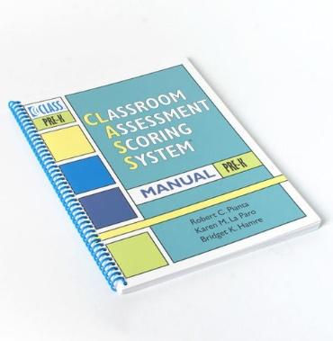 **Teacher’s Name(s): \_\_\_\_\_\_\_\_\_\_\_\_\_\_\_\_\_\_\_\_\_\_\_\_\_\_\_\_\_\_\_\_\_\_\_\_\_\_\_\_\_\_\_\_\_\_ Classroom: \_\_\_\_\_\_\_\_\_\_\_\_\_\_\_\_\_\_\_\_\_\_\_\_\_\_\_\_\_\_\_\_\_\_\_\_\_\_\_\_\_\_\_\_\_  
  
Program: \_\_\_\_\_\_\_\_\_\_\_\_\_\_\_\_\_\_\_\_\_\_\_\_\_\_\_\_\_\_\_\_\_\_\_\_\_\_\_\_\_\_\_\_\_\_\_\_\_\_\_\_\_\_\_\_\_\_\_\_\_ Date: \_\_\_\_\_\_\_\_\_\_\_\_\_\_\_\_\_\_\_\_\_\_\_\_\_\_\_\_\_\_\_\_\_\_\_\_\_\_\_\_\_\_\_\_\_**   
**What is Pre-K CLASS?**The Pre-K Classroom Assessment Scoring System® (CLASS®) focuses on the effectiveness and quality of teacher-child interactions for children 3 years to 5 years old. This includes:

* How teachers build relationships with and positively interact with children
* How teachers recognize and respond to children’s needs
* How teachers support and motivate children’s learning, and engagement
* How classroom organization and time management impact learning
* How teachers use instructional strategies that promote higher-order thinking
* How teachers provide feedback to expand children’s participation
* How teachers encourage language development

**What is the Purpose of Self-Reflection?**This self-reflection guide is developed to help you become more familiar with the Pre-K CLASS® measure and reflect on your current practices around teacher-child interactions. This guide can be used independently by teachers and classroom teams, or it can be used with support from Technical Assistance Providers. Be as open and honest as you can during this self-reflection process.

**How does the Self-Reflection Guide work?**  
The self-reflection guide includes statements and open-ended questions for you to read and reflect on. This allows you to identify strengths and areas for growth in your caregiving interactions. Throughout this guide, a rating of **rarely, occasionally, or regularly** will be noted based on the consistency of your behaviors or interactions described for each dimension.

This guide was organized to align with the three Pre-K CLASS® domains and ten dimensions as shown below:

|  |  |  |
| --- | --- | --- |
| **Emotional Support** | **Classroom Organization** | **Instructional Support** |
| Positive Climate  Negative Climate  Teacher Sensitivity  Regard for Student Perspectives | Behavior Management  Productivity  Instructional Learning Formats | Concept Development  Quality of Feedback  Language Modeling |

|  |
| --- |
| **KEEP IN MIND** |
| There are different ways to reflect on the frequency of your practices. Depending how you decide to use this self-reflection guide, you could have different answers.   * How often does something occur during your day as a whole? * How often does something occur during one time of day (e.g. transitions, meals, free play, group time, etc.)? |

The **Emotional Support** Domain assesses interactions between teachers and children that promote a positive classroom climate, including positive relationships and respect between teachers, children and peers. This domain measures teacher’s acknowledgement of children’s feelings or emotions, their responsiveness to children, awareness and support of children’s academic, social and emotional needs, promotion of children’s independence, and emphasis on children’s interests, ideas and points of view.

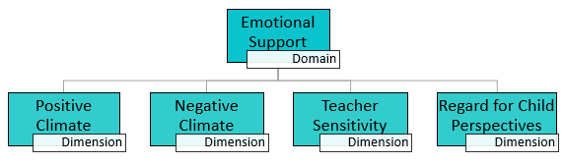

|  |  |  |  |
| --- | --- | --- | --- |
| **Positive Climate** includes the following four indicators that reflect the connection between the teachers and children, and among children, and the warmth, respect, and enjoyment communicated verbally and nonverbally. | | | |
|  | Rarely | Occasionally | Regularly |
| I sit or stand near the children and participate in activities and routines with them. |  |  |  |
| I smile and laugh with the children frequently. |  |  |  |
| I share verbal and non-verbal affection with the children (e.g., high fives, hugs, acknowledgment, recognition) |  |  |  |
| I am respectful when interacting with children (e.g., warm, calm tone of voice, using children’s names, body orientation) |  |  |  |
| How do I build warm, supportive relationships with each child I work with? | | | |
| How am I encouraging positive interactions and relationships between children? | | | |

|  |  |  |  |
| --- | --- | --- | --- |
| **Negative Climate** includes four indicators that measure the overall level of expressed negativity in the classroom, including teacher and peer negativity. | | | |
|  | Rarely | Occasionally | Regularly |
| I express irritation or frustration towards children through words, tone of voice, or body language. |  |  |  |
| I yell, use threats or physical actions to control children. |  |  |  |
| I criticize and shame children in front of their peers. |  |  |  |
| How are my attitudes and emotions shaping the learning environment? | | | |
| In what ways might my interactions negatively impact the children or group? | | | |

|  |  |  |  |
| --- | --- | --- | --- |
| **Teacher Sensitivity** includes four indicators that measure a teacher's awareness and responsivity to the children’s academic and emotional needs. | | | |
|  | Rarely | Occasionally | Regularly |
| I notice the children’s needs and feelings throughout the day. |  |  |  |
| I respond to children’s comments, questions, or signals that they need help or attention. |  |  |  |
| The children are comfortable seeking support from and sharing their ideas with me. |  |  |  |
| What do I do during an activity when I notice a lack of understanding or difficulties? | | | |
| How do I address children’s problems and concerns, so they do not continue or increase and are resolved? | | | |

*re-*

*K Classroom Assessment Scoring System® (CLASS®) Internal Self-Reflection Tool*

|  |  |  |  |
| --- | --- | --- | --- |
| **Regard for Child Perspectives** includes four indicators that measure how a teacher’s interactions include the children’s interests, motivations, and points of view. | | | |
|  | Rarely | Occasionally | Regularly |
| My learning activities are built around children’s interests and ideas. |  |  |  |
| I give children choices and responsibilities in the classroom. |  |  |  |
| I provide frequent opportunities for children to talk and express their thoughts. |  |  |  |
| During teacher-planned activities, how do I ensure that children are playing an active role in their learning? | | | |
| How am I allowing children to freely move and position themselves during activities (free play, whole group, small group, etc.)? | | | |

The **Classroom Organization** Domain assesses classroom organization and management of children’s behavior, time, and attention in the classroom. This domain measures the stability of the schedule and routines, clarity of expectations, and using sensitive and appropriate guidance strategies. It also looks at how teachers maximize and support learning opportunities.

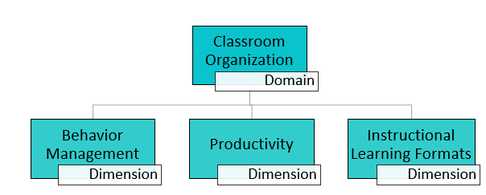

|  |  |  |  |
| --- | --- | --- | --- |
| **Behavior Management** includes four indicators that measure a teacher’s ability to provide clear expectations and use effective methods to prevent and redirect misbehavior in a developmentally informed manner. | | | |
|  | Rarely | Occasionally | Regularly |
| I state clear and consistent expectations for behavior before all activities/routines. |  |  |  |
| I am aware of, and attend to, children in all areas of the classroom, even when working with an individual student or small group. |  |  |  |
| I effectively redirect misbehavior without interrupting classroom activities and make sure to use positive phrases (e.g. “Walking feet,” instead of “Stop running”). |  |  |  |
| How do I support children struggling to resolve conflicts or regulate emotions? | | | |
| When I anticipate that misbehavior might occur during a classroom routine or activity, what methods do I use to prevent these problems from developing? | | | |

|  |  |  |  |
| --- | --- | --- | --- |
| **Productivity** includes four indicators that measure how well a teacher manages time and routines, so that children can remain involved in activities. | | | |
|  | Rarely | Occasionally | Regularly |
| When finished with an activity or routine in my schedule, I provide children with other activity choices, so they do not need to wait for everyone else to finish. |  |  |  |
| The children know what they should be doing; they do not show confusion by wandering, and I do not need to provide additional directions or instructions. |  |  |  |
| I prepare activity materials in advance and make sure they are easily accessible. |  |  |  |
| How do I deal with disruptions and completion of routine tasks (cleaning, paperwork, etc.), so they do not take away from learning opportunities? | | | |
| In what ways do I plan for transitions (e.g. provide warnings, include ways to keep them engaged, etc.)? | | | |

|  |  |  |  |
| --- | --- | --- | --- |
| **Instructional Learning Formats** includes four indicators that measure the ways a teacher maximizes the children’s interest, engagement, and ability to learn from lessons and activities. | | | |
|  | Rarely | Occasionally | Regularly |
| I get involved, ask questions, and encourage children’s participation during group, play, and routine activities. |  |  |  |
| I use a variety of modalities (auditory, visual, movement), materials, and hands-on opportunities to keep children engaged. |  |  |  |
| During activities, the children are excited, actively participating, and listening. |  |  |  |
| How do I communicate the purpose or objectives of a lesson or activity, and ensure that children remain focused on it? | | | |
| Are there times during the classroom day when my involvement in learning activities or routines could be more active and intentional? | | | |

The **Instructional Support** Domain assesses how teachers implement lessons and activities to promote cognitive and language development. This domain measures how teachers support and extend children’s analytical thinking, conversational skills, and vocabulary. It also looks at teachers providing children with the amount of help they need, and the quality of teacher feedback that acknowledges children’s attempts and increases their involvement.

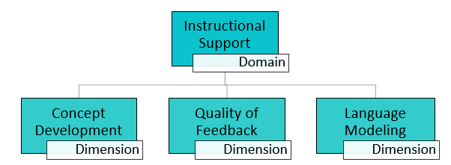

|  |  |  |  |
| --- | --- | --- | --- |
| **Concept Development** includes four indicators that measure a teacher’s use of instructional discussions and activities to promote higher-order thinking skills, rather than rote instruction. | | | |
|  | Rarely | Occasionally | Regularly |
| I ask questions that encourage children to think about the how’s and why’s of learning; focusing their attention on the process rather than on just getting the correct answer. |  |  |  |
| I provide opportunities for children to use critical thinking; classifying/comparing, predicting/experimenting, problem-solving, and evaluating. |  |  |  |
| I encourage children to create their own products and generate their own ideas by asking them to brainstorm and plan. |  |  |  |
| How do I tie new information we are discussing to previous activities/learning and what the children already know? | | | |
| In what ways have I related the concepts we were discussing to the children’s actual life experiences? | | | |

|  |  |  |  |
| --- | --- | --- | --- |
| **Quality of Feedback** includes five indicators that measure how teachers provide feedback in a way that expands children’s learning and understanding. | | | |
|  | Rarely | Occasionally | Regularly |
| I ask children to explain why they are doing something or how they got an answer. |  |  |  |
| When children reply or comment, I clarify and add information, so they walk away with a deeper understanding and new information. |  |  |  |
| Rather than just saying “Good job,” I provide children with specific feedback that encourages their efforts and persistence in activities. |  |  |  |
| How do I scaffold for children when they have a hard time understanding a concept, answering a question, or completing an activity? What about the children who need more of a challenge? | | | |
| How do I ensure that the back-and-forth exchanges I have with children are not just question and response, but that I am promoting further learning and thinking on the part of the child? | | | |

|  |  |  |  |
| --- | --- | --- | --- |
| **Language Modeling** includes five indicators that measure the quality and amount of a teacher’s use of language facilitation strategies. | | | |
|  | Rarely | Occasionally | Regularly |
| I have conversations with children throughout the day and encourage children to talk to each other. |  |  |  |
| I ask questions that extend the conversation and encourage longer, more complex answers; not just asking for yes/no or right/wrong responses. |  |  |  |
| I introduce new words to children, explain what they mean, and make sure to use the word throughout the day. |  |  |  |
| When do I have sustained conversations with children? Are there times during the day when this could be happening more? | | | |
| How do I model language for children? Reflect on if you ever state out loud what you or the children are doing as those actions are occurring. | | | |