|  |
| --- |
| **Infant Classroom Assessment Scoring System® (CLASS®) Self-Reflection Guide** |

**Teacher’s Name(s): _______________________________________________ Classroom: ______________________________________________  
  
Program: ______________________________________________________________ Date: ______________________________________________   
  
What is Infant CLASS?**  
The Infant Classroom Assessment Scoring System® (CLASS®) focuses on the effectiveness and quality of teacher-child interactions for children 6 weeks to 18 months. This includes: 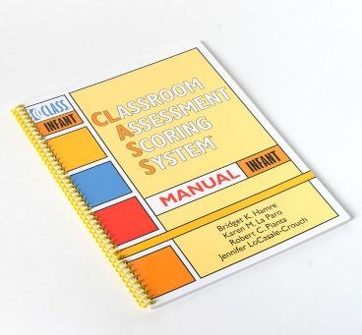

* The extent to which teachers build nurturing and trusting connections with infants and act as a secure base for exploration
* How teachers sensitively respond to individual cues and needs
* How teachers encourage early language development
* The presence and quality of opportunities provided for infants to learn and build strong foundations for social, emotional, and cognitive development

**What is the Purpose of Self-Reflection?**  
This self-reflection guide is developed to help you become more familiar with the Infant CLASS® measure and reflect on your current practices around teacher-child interactions. This guide can be used independently by teachers and classroom teams or it can be used with support from Technical Assistance Providers. Be as open and honest as you can during this self-reflection process.

**How does the Self-Reflection Guide work?**  
The self-reflection guide includes statements and open-ended questions for you to read and reflect on. This allows you to identify strengths and areas for growth in your caregiving interactions. Throughout this guide, a rating of **rarely, occasionally, or regularly** will be noted based on the consistency of behaviors or interactions described for each dimension.

This guide was organized to align with the one Infant CLASS® domain and four dimensions as shown:

|  |  |
| --- | --- |
| **Responsive Caregiving** | |
| Relational Climate  Teacher Sensitivity | Facilitated Exploration  Early Language Support |

|  |
| --- |
| **KEEP IN MIND** |
| There are different ways to reflect on the frequency of your practices. Depending how you decide to use this self-reflection guide, you could have different answers.   * How often does something occur during your day as a whole? * How often does something occur during one time of day (e.g. transitions, meals, free play, group time, etc.)? |

The **Responsive Caregiving** domain assesses the positive connection between teachers and children, including joint attention and enjoyment, a respectful and gentle approach used by teachers, and lack of negativity. This domain measures teachers’ responsiveness to children’s emotions and needs, their interactions and involvement during routine care and play, how they follow the children’s lead and provide them with choices, their use of language to label and describe, and their use of imitation and repetition when children use language.   
 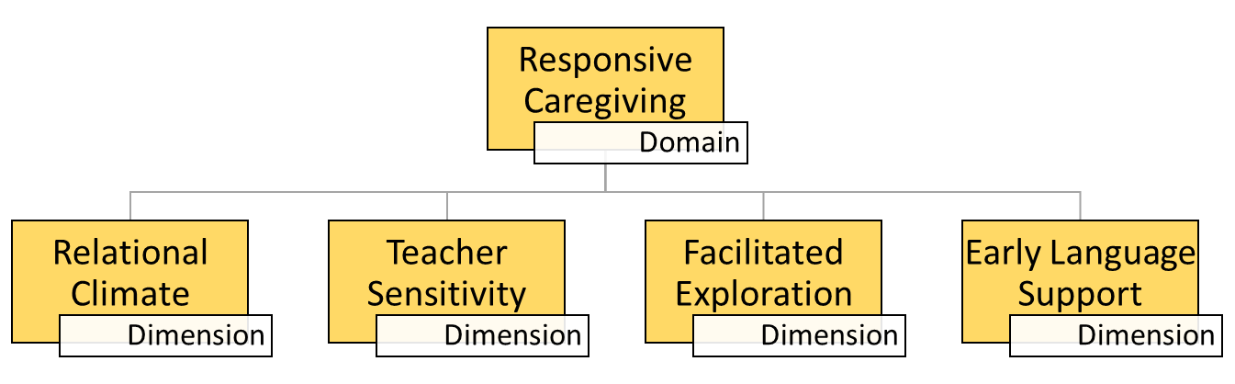

|  |  |  |  |
| --- | --- | --- | --- |
| **Relational Climate** includes four indicators that measure the connection, emotions, and respect that teachers show infants. | | | |
|  | Rarely | Occasionally | Regularly |
| I sit with the infants on their level and join in their play and activities. |  |  |  |
| I provide the infants with verbal and physical affection (e.g. gentle touches, hugs, positive comments). |  |  |  |
| The infants and I smile and laugh together. |  |  |  |
| I use a warm, calm tone of voice with infants. |  |  |  |
| I display irritation or frustration during my interactions with infants or other adults. |  |  |  |
| How do I build warm and supportive relationships with each infant I work with? | | | |
| How do I communicate intentions, transitions, or changes to infants before acting on them? (e.g. letting the infant know you will be wiping their nose before physically touching them.) | | | |
| In what ways might my attitudes, emotions, or interactions negatively impact the children or group? | | | |

|  |  |  |  |
| --- | --- | --- | --- |
| **Teacher Sensitivity** includes three indicators that measure how aware a teacher is of infants' verbal and non-verbal cues and how timely and successful they are at responding. | | | |
|  | Rarely | Occasionally | Regularly |
| During routines and activities, I position my body so it is turned towards the infants and I can easily look around the room. |  |  |  |
| I take notice and acknowledge infants who are making bids for my attention, as well as those who are not. |  |  |  |
| I quickly recognize and respond to the infant’s positive and negative emotions and their need for attention, comfort, or assistance. |  |  |  |
| The infants look for and reach for me when trying something new and when they are upset. |  |  |  |
| What verbal and nonverbal (physical) cues do the infants give when indicating a need for help or attention? How do I respond to those cues? Am I always able to respond in a timely manner? Why or why not? | | | |
| If an infant is sending me signals but I can’t get to them immediately, how do I let them know that I am coming? | | | |
| How do I adjust my responses/actions based on the needs of the infants? (e.g. when trying to soothe a crying infant I try to engage them with a rattle, but when that doesn’t seem to be working I switch to rocking them instead.) | | | |

d

|  |  |  |  |
| --- | --- | --- | --- |
| **Facilitated Exploration** includes three indicators that measure how a teacher supports exploration for infants as a way of supporting their development. | | | |
|  | Rarely | Occasionally | Regularly |
| I move around the room, playing with and talking to the infants, during play and routines (e.g. diaper changes, feeding, etc.). |  |  |  |
| I imitate infants’ behaviors/actions (e.g. clapping your hands together in response to an infant clapping their hands). |  |  |  |
| I provide opportunities and time for infants to explore the room and materials on their own, safely. |  |  |  |
| I support infant’s engagement and development by verbally encouraging them or adding to an experience (e.g. excitedly saying “You can do it!” as an infant learning to crawl moves toward a toy or showing them how to push a button that causes an effect on the toy they are touching). |  |  |  |
| How do I use routine times (diaper changes, mealtimes, etc.) to interact and communicate with infants, one-on-one? | | | |
| How do I know an infant is interested in learning more about or exploring something? What are some signals that show me they are not interested in an activity or material? | | | |
| How am I encouraging peer interactions in the classroom? | | | |

|  |  |  |  |
| --- | --- | --- | --- |
| **Early Language Support** includes three indicators that measure the quality and amount of communication used between teachers and infants. | | | |
|  | Rarely | Occasionally | Regularly |
| I label and describe objects, people, and pictures in the classroom. |  |  |  |
| I use complete sentences and descriptive words when speaking to and interacting with infants. |  |  |  |
| I encourage infants to talk by imitating and initiating sounds or words with them. |  |  |  |
| I respond to infants’ communication attempts and actions by adding more words or phrases. (e.g. when an infant says “da” and points to a picture, I extend this by stating “That’s a white dog and they go woof, woof.”) |  |  |  |
| How do I model language for infants? Do I verbally describe what I am doing or infants’ actions during play and routines? | | | |
| What techniques do I use to engage infants in back-and-forth exchanges? How do I encourage and model turn-taking during these conversations? | | | |
| How do I have conversations with non-verbal infants? What are some ways non-verbal infants might communicate with me? | | | |