|  |
| --- |
| **Infant Toddler Environment Rating Scale (ITERS-3) Self-Reflection Guide** |

**Teacher’s Name(s): __________________________________________________ Classroom: __________________________________________**

**Program: ______________________________________________________________ Date: ________________________________________________**

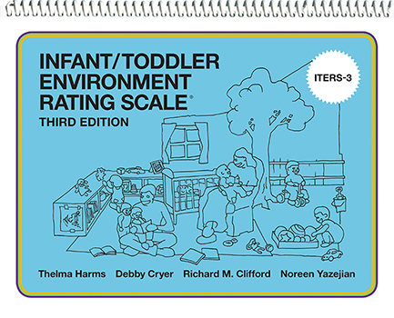

**What is ITERS?**ITERS views child development from a global point of view, measuring a wide variety of areas that all contribute to children’s positive development in classrooms serving children where the majority are ages birth up to age three.

This includes:

* Protection of children’s health and safety
* Supporting and guiding social/emotional development
* Opportunities for intellectual and language stimulation and appropriate learning activities

All three components are needed to create quality education. Each of these three basic components can be observed in the program’s environment, curriculum, schedule, supervision and interaction.

**What is the Purpose of Self-Reflection?**This self-reflection guide is developed to help you become more familiar with the ITERS measure and reflect on your current practices. This guide can be used independently by teachers and classroom teams or it can be used with support from Technical Assistance Providers. Be as open and honest as you can during this self-reflection process.

**How does the Self-Reflection Guide work?**  
The self-reflection guide includes statements and open-ended questions for you to read and reflect on. This allows you to identify strengths and areas for growth in your caregiving interactions. Throughout this guide, a rating of **rarely, occasionally, or regularly** will be noted based on the consistency of your behaviors or interactions described for each dimension.

This guide was organized to align with the six ITERS subscales that measure observable quality practices:

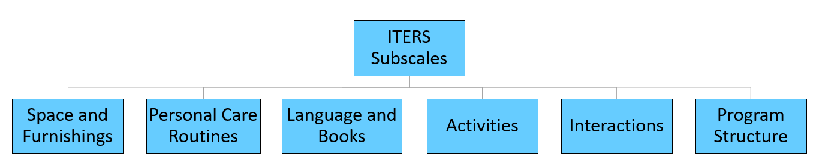

The **Space and Furnishings** subscale includes the items noted below. This subscale captures how indoor and outdoor spaces can be designed to encourage movement, exploration, and overall child development.

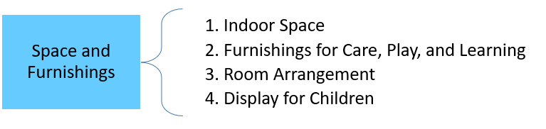

|  |  |  |  |
| --- | --- | --- | --- |
| **PAUSE TO THINK** | | | |
| Why might this subscale and the associated items be important to a child’s development? | | | |
|  | Rarely | Occasionally | Regularly |
| I check that the spaces and furnishings are clean and safe for children to use and promote learning. |  |  |  |
| I move about the room while children are playing to supervise and support their learning opportunities in different areas. |  |  |  |
| I use the displayed materials as a teaching tool with children during different times of day. |  |  |  |
| I intentionally display simple pictures, posters, and photographs of the children, their families, pets, and other familiar experiences on a level the children can easily see. |  |  |  |
| How do I know when there is a need to adjust the temperature or airflow in my classroom? How do I resolve this need (e.g. fans, heat or AC control, etc.)? | | | |
| How do I set up each center/play area so that children know how to focus their play, and in a way that is appropriate for their ages and abilities? | | | |
| How do I arrange my classroom in a proactive way to be able to see and hear all children? When there are challenges that furnishings cause with supervision, how do I navigate the space to prevent problems? | | | |
| What do I need in the routine care areas (e.g. mealtime, diapering/toileting, naptime) of my classroom that will allow me to complete routines with the children easily and efficiently? | | | |

The **Personal Care Routines** subscale includes the items noted below. This subscale measures how teachers support children in learning proper procedures around health and safety practices, as well as the interactions during these routine times.

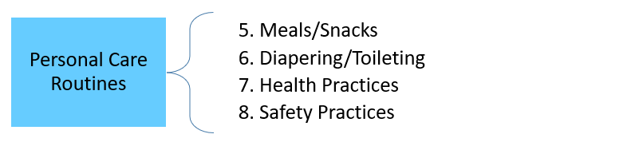

|  |  |  |  |
| --- | --- | --- | --- |
| **PAUSE TO THINK** | | | |
| What role does health and safety play in children’s overall development and why is it important? | | | |
|  | Rarely | Occasionally | Regularly |
| I support children to ensure that they understand and complete proper handwashing with only minor lapses in the required procedure. |  |  |  |
| I engage positively with children during routines, such as diapering/toileting, handwashing, and mealtimes. |  |  |  |
| I am aware of children’s individual routine needs, such as diapering/toileting, signs of hunger and tiredness, and adjust the schedule to meet them. |  |  |  |
| I review, practice, and refine my skills related to the required sanitary procedures for diapering. |  |  |  |
| I notice and stop unsafe behavior and explain the reason why the action is unsafe. |  |  |  |
| How do I actively adjust my supervision based on the ages/abilities of the children, the relative risks, and the developmental characteristics of the children in my group? | | | |
| What risks might the children in my classroom experience during mealtime? In what ways might the children need support and supervision to lessen those risks? | | | |
| How do I teach self-help skills as children complete routines throughout the day? | | | |
| How can I minimize potential hazards to make sure indoor and outdoor spaces are physically safe for children? | | | |

The **Language and Books** subscale includes the following items noted below. This subscale focuses on how teachers support children’s language growth and literacy development through the quality and frequency of their interactions with children, their use of descriptive language, and their use of books.

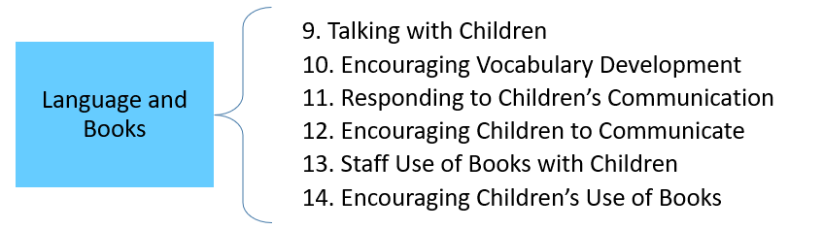

|  |  |  |  |
| --- | --- | --- | --- |
| **PAUSE TO THINK** | | | |
| Why might this subscale and the associated items be important to a child’s development? | | | |
|  | Rarely | Occasionally | Regularly |
| I use the names of people, places, things, and actions as children experience them in routines and play. |  |  |  |
| I engage in serve and return interactions (initiating and responding to verbal and non-verbal communication) with children at different times throughout the day. |  |  |  |
| I respond to children’s attempts to communicate (upset and non-upset children) with a timely and positive response that satisfies the child. |  |  |  |
| I use books with children, either as a whole group, small group, or individually. |  |  |  |
| While I read books with children, I point to and talk about the pictures. |  |  |  |
| I encourage children to access books independently. |  |  |  |
| How do I create opportunities provided by toys, materials, and displays to introduce new words and/or ideas to children of different ages/abilities? | | | |
| How can I create opportunities for the children to discuss past and future experiences, while still balancing talk about the “here and now” for children? | | | |
| What strategies do I use to make book times attractive to children? What shows me that a book time is no longer engaging or meeting their needs? How do I transition to a new activity if it seems needed? | | | |

The **Activities** subscale includes items listed below. This subscale assesses the materials accessible to the children, the time they have to play with those materials and the support the teachers provide to further learning in specific skill areas.

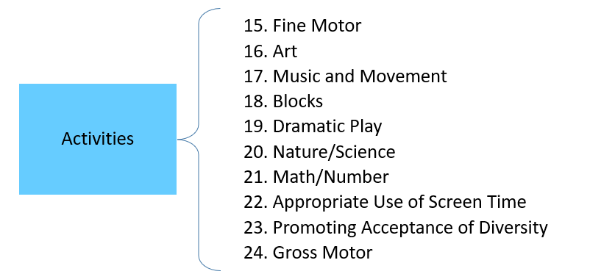

|  |  |  |  |  |
| --- | --- | --- | --- | --- |
| **PAUSE TO THINK** | | | | |
| Why is access to materials important? How can barriers in accessing materials (out of reach, children restricted from using, waiting with nothing to do) affect a child’s development? | | | | |
|  | | Rarely | Occasionally | Regularly |
| As children play with the following materials, I am an engaged participant in their play  (e.g. I ask questions to stimulate children’s thinking and reasoning, encourage experimentation, make connections to learning and concepts, and engage in conversations to extend their interest) | Fine Motor Materials |  |  |  |
| Art Materials (18 months and older) |  |  |  |
| Blocks and Accessories |  |  |  |
| Materials for Dramatic Play |  |  |  |
| Nature/Science Materials |  |  |  |
| Materials for Math or with Numbers |  |  |  |
| Materials Promoting Diversity |  |  |  |
| Materials for Gross Motor |  |  |  |
| I provide opportunities for the children to engage in music and movement (singing, dancing, movement) during different activities throughout the day. | |  |  |  |
| I encourage children’s vigorous gross motor activity by providing time and space for children to be actively engaged. | |  |  |  |
| I provide a variety of equipment that stimulates different gross motor skills (e.g. jumping, climbing, balancing and sliding). | |  |  |  |
| How can I create a process that allows me to notice when children are not engaged with materials or activities that they enjoy? | | | | |
| How do I ensure that children of all abilities (mobile and non-mobile) have time for meaningful play with a variety of materials of their choice? | | | | |
| How can I ensure children can experience living things both indoors and outdoors, realistic nature/science materials and sand/water opportunities*? (*Sand/water access for children 24 months and older, with appropriate supervision) | | | | |
| How can I utilize different activities to encourage math learning (while children are using math materials, engaging in routines, and playing with non-math materials)? | | | | |
| How do I promote diversity (race, culture, age, abilities, gender in a non-stereotypical role) by providing opportunities for children to see the similarities and differences among people, both within learning activities and conversations? | | | | |

The **Interactions** subscale includes the following items below. This subscale measures how teachers handle guiding children’s behavior, supervise their play and interact with children to individualize their learning in various areas.

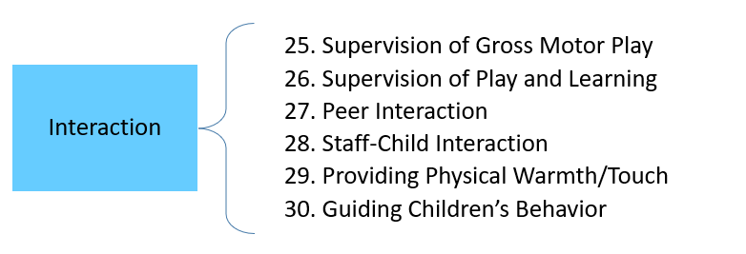

|  |  |  |  |
| --- | --- | --- | --- |
| **PAUSE TO THINK** | | | |
| What types of interactions support growth and development for children? What types of interactions might hinder a child’s development? | | | |
|  | Rarely | Occasionally | Regularly |
| I encourage vigorous gross motor activity that develops new gross motor skills. |  |  |  |
| I interact with the children in my care in a warm, positive way. |  |  |  |
| I provide opportunities for the children to choose who they want to play with and the materials they want to use. |  |  |  |
| I sit on the floor or down low to make myself physically accessible to the children. |  |  |  |
| I positively encourage and model what a “gentle touch” looks like during peer conflicts and as an act of affection. |  |  |  |
| During the following times, how do I use physical contact?  Transitions:    Routines:    Play times:    While guiding behavior: | | | |
| How do I know if my physical contact is positively received by children? | | | |
| When children show anxiety, fear, discomfort, or anger, how will I show I care about and respect them through supportive interactions? | | | |
| How do I support positive interactions between peers?  When problems with peers happen, how can I adjust my support? | | | |
| How do I draw attention to instances of positive interactions among children? | | | |
| What strategies can I use to evaluate the expectations I set for the children in my room and whether they are appropriate for the children?  When children follow directions/expectations, how do I respond? | | | |

The **Program Structure** subscale includes the items below. This subscale assesses the structure of the classroom day, opportunities for children to experience free play, and the meaningful experiences children have if whole group activities occur.

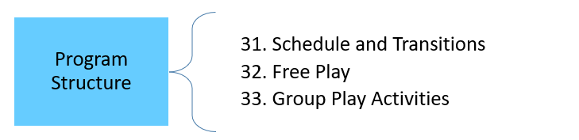

|  |  |  |  |
| --- | --- | --- | --- |
| **PAUSE TO THINK** | | | |
| Why might this subscale and the associated items be important to a child’s development? | | | |
|  | Rarely | Occasionally | Regularly |
| The wait times that children experience during transitions are less than three minutes. |  |  |  |
| I am prepared for what comes next in the schedule, so children do not experience delayed routines or activities. |  |  |  |
| I provide free play opportunities where children are allowed to make independent selections from the materials in the room. |  |  |  |
| Play times include a variety of materials and equipment so children experience engaging play with little competition over materials. |  |  |  |
| What strategies can I use to keep children engaged during transitions? | | | |
| During free play times, how do I ensure that children of all abilities (e.g. mobile and non-mobile) receive meaningful interactions and experiences? | | | |
| During free play times, how can I utilize each of the following strategies to encourage productive play?    Materials in reach of children:    Organization of play materials:  Maintaining play areas: | | | |
| If I choose to offer whole group activities, how can I plan to make them engaging and flexible? | | | |
| If I choose to offer whole group activities, what do I need to do to notice the children’s cues that they may no longer be interested?  How can I show responsiveness to those cues to meet children’s needs (e.g. allow children to leave, provide alternate activities, adjust activity for future)? | | | |