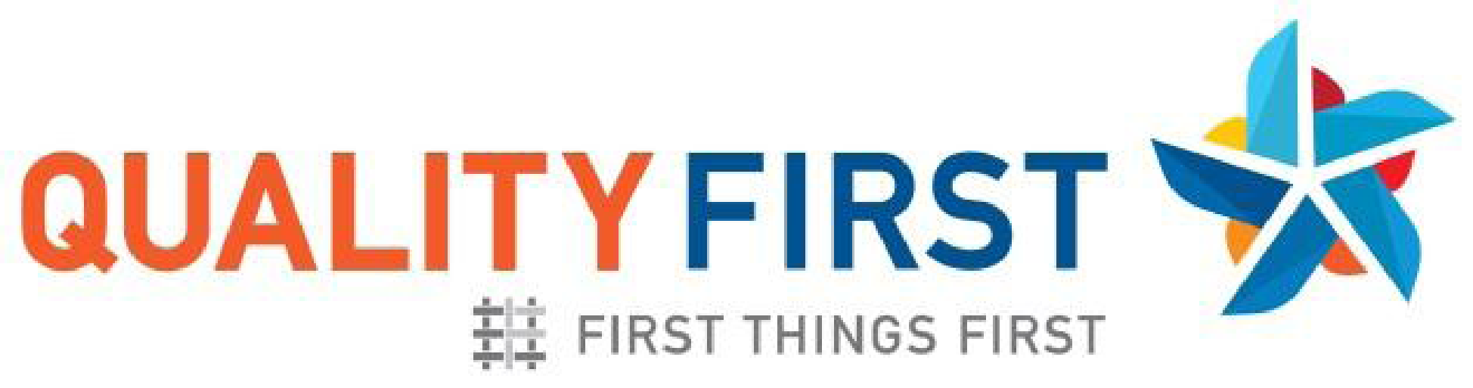 | Quality In Action Program Spotlight

Participant Name and Address: | Participant ID#: | Quality First Participant Since:
First Things First Region: | Main Contact:

The Quality First website, QualityFirstAZ.com provides a wealth of resources and information for early care and education professionals. The Quality First blog features new posts each month to provide information and inspiration to early childhood professionals, including success stories, tips, and ideas from others in the field.
Do you have a new, innovative, or successful practice to share with others? Please complete the questions below and submit it to QualityFirst@FirstThingsFirst.org. You will be contacted to discuss your submission and plans for publication. If you have photos of the practice, please submit those to be included as well. (If children or adults are included in the photos, please submit an FTF Photo Video Consent Release for each person.) You may attach a separate sheet if needed.
- Summary of the Quality in Action practice.

- What made you start this practice?

- Was there a barrier you were hoping to overcome?

- Where did you get the idea and what resources did you use?

- How is this practice improving the quality of your program and what have others noticed?

- What might you tell a colleague if they were to be interested in incorporating similar ideas?

